**NAME –** DEVANGI PURKAYASTHA

**REGISTRATION NUMBER –** RA1811003010689

**SECTION-** D2

LAB EXP:8 COMPUTATION OF LEADING AND TRAILING SETS DATE: 19 March 2021

**AIM : To Compute Leading and Trailing Sets**

**CODE:**

a = ["E=E+T",

     "E=T",

     "T=T*F",

     "T=F",

     "F=(E)",

     "F=i"]

rules = {}

terms = []

for i in a:

    temp = i.split("=")

    terms.append(temp[0])

    try:

        rules[temp[0]] += [temp[1]]

    except:

        rules[temp[0]] = [temp[1]]

terms = list(set(terms))

print(rules,terms)

def leading(gram, rules, term, start):

    s = []

    if gram[0] not in terms:

        return gram[0]

    elif len(gram) == 1:

        return [0]

    elif gram[1] not in terms and gram[-1] is not start:

        for i in rules[gram[-1]]:

            s+= leading(i, rules, gram[-1], start)

            s+= [gram[1]]

        return s

def trailing(gram, rules, term, start):

    s = []

    if gram[-1] not in terms:

        return gram[-1]

    elif len(gram) == 1:

        return [0]

    elif gram[-2] not in terms and gram[-1] is not start:

        for i in rules[gram[-1]]:

            s+= trailing(i, rules, gram[-1], start)

            s+= [gram[-2]]

        return s

leads = {}

trails = {}

for i in terms:

    s = [0]

    for j in rules[i]:

        s+=leading(j,rules,i,i)

    s = set(s)

    s.remove(0)

    leads[i] = s

    s = [0]

    for j in rules[i]:

        s+=trailing(j,rules,i,i)

    s = set(s)

    s.remove(0)

    trails[i] = s

for i in terms:

    print("LEADING("+i+"):",leads[i])

for i in terms:

    print("TRAILING("+i+"):",trails[i])

**ALGORITHM-**

Leading and Trailing are functions specific to generating an operator-precedence parser, which is only applicable if you have an operator precedence grammar. An operator precedence grammar is a special case of an operator grammar, and an operator grammar has the important property that no production has two consecutive non-terminals.

(An operator precedence grammar is, loosely speaking, an operator grammar which can be parsed with an operator precedence parser)

Given an operator grammar, the function Leading (resp. Trailing) of a non-terminal produces the set of terminals which could be (recursively) the first (resp. last) terminal in a production for that non-terminal.

Another way to think of that a terminal is in the Leading set for a non-terminal if it is "visible" from the beginning of a production. We consider non-terminals to be "transparent", so a terminals could be visible through a non-terminal or by looking into a visible non-terminal.

**OUTPUT** –

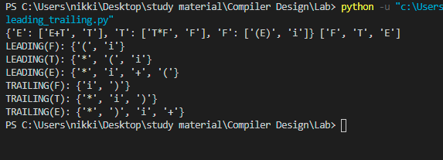

**RESULT –**

The given program has been successfully executed.